

REACT JS PROJECT REPORT ON
TITLE OF THE PROJECT

Submitted by
THRISHA G
24BIT060

Under the Guidance of
ARAVIND
Technical Trainer
Technical Department, KG College of Arts and Science

Academic Year: 2025 – 2026
APRIL 2026

DECLARATION
I hereby declare that the project entitled “LIBRARY SEAT RESERVATION SYSTEM” submitted in partial fulfillment of the requirements for the course REACT JS is a record of my original work carried out under the guidance of ARAVIND, Technical Trainer, Technical Department, KG College of Arts and Science.
I further declare that this project has not been submitted previously, either in part or in full, for the award of any degree, diploma, or other similar title, at this or any other institution.
I have acknowledged all sources of information used in this project wherever applicable.

April 2026
Coimbatore

Thrisha G ________________________
(Your Name)

CERTIFICATE
This is to certify that the project entitled “LIBRARY SEAT RESERVATION SYSTEM” is a bona fide work carried out by THRISHA G, II-A, BSC.INFORMATION TECHNOLOGY , KG College of Arts & Science, in partial fulfillment of the requirements for the course REACT JS.
This project has been completed under my supervision and guidance during the academic period April 2026.

Place: COIMBATORE
Date:09.04.2026

Submitted for the Viva-Voce Examination held on ____________09.04.2026______________________

Guide: Head of the Department
(Technical Trainer, KGCAS) (Technical Head, KGCAS)

______________________ _______________________

TABLE OF CONTENTS
S. No. | Topics | Page. No.
1 | Introduction
1.1 | Background of the Study
1.2 | Problem Statement
1.3 | Objectives of the Project
1.4 | Purpose and Significance
1.5 | Scope and Limitations
1.6 | Methodology Overview
2 | System Analysis
2.1 | Existing System
2.2 | Drawbacks of the Existing System
2.3 | Proposed System
2.4 | Features of the Proposed System
2.5 | Feasibility Study
2.6 | Requirement Analysis
3 | System Design
3.1 | System Architecture
3.2 | Use Case Diagram
3.3 | Data Flow Diagram (DFD)
3.4 | Entity Relationship Diagram (ERD)
3.5 | User Interface Design
4 | System Implementation
4.1 | Development Tools
4.2 | Module Description
4.3 | Algorithms
4.4 | System Integration
4.5 | Security and Validation
5 | System Testing
5.1 | Testing Methodology
5.2 | Test Cases
5.3 | Error Handling
5.4 | Performance
6 | Input and Output Screens
6.1 | System Outputs
6.2 | Discussion
6.3 | Comparison
6.4 | User Feedback
7 | Conclusion and Future Enhancement
7.1 | Summary
7.2 | Limitations
7.3 | Future Scope
8 | References
Appendices
- Source Code Snippets
- Screenshots of Web Pages

ABSTRACT
The Smart Library Seat Booking System is a web-based application developed using React JS to manage and optimize seat allocation in a library environment. The system allows users to log in, select time slots (morning, afternoon, evening), and reserve or book available seats in real time.
The application provides an interactive and user-friendly interface where users can view seat availability, reserve seats, confirm bookings, and cancel their own reservations. The system also includes features such as notifications, dashboard analytics, filters for time slots, and dark/light mode for better user experience.
React JS is used for dynamic UI rendering and state management, enabling smooth interaction without page reloads. The system ensures efficient seat utilization and reduces manual effort in managing library seating.
This project demonstrates how modern frontend technologies can be used to build real-time interactive systems and can be extended with backend integration for large-scale deployment.
Chapter 1: Introduction

1.1 Background of the Study
In modern educational environments, libraries face challenges in managing seating efficiently due to increasing student usage. Traditional seat allocation methods are manual and time-consuming. With the advancement of web technologies, automated systems can improve seat management and user convenience.
This project introduces a Smart Library system using React JS that enables students to book and manage seats digitally.
1.2 Problem Statement
Manual seat allocation in libraries leads to several issues such as inefficient utilization of available seats, lack of real-time availability information, and conflicts between users. There is no proper system to track reservations or manage time slots effectively. These challenges highlight the need for a digital system that can provide real-time seat booking and management.
1.3 Objectives of the Project
The main objective of this project is to design and develop a web-based seat booking system using React JS. The system aims to allow users to reserve and confirm seats easily while managing different time slots effectively. It also focuses on providing real-time updates, improving user interaction, and enhancing the overall user experience with features like notifications and theme customization.
1.4 Purpose and Significance of the Study
The purpose of this project is to provide a simple and efficient solution for managing library seating. It helps reduce manual effort and improves the utilization of available resources. The system contributes to digital transformation in educational environments by offering a user-friendly and interactive platform for students.
1.5 Scope and Limitations
Scope:
The scope of this project includes the development of a front-end based seat booking system that allows users to reserve, confirm, and cancel seats based on selected time slots.
Limitations:
The current system does not include backend integration or database storage, and it operates as a prototype using in-memory or local data handling techniques.
1.6 Methodology Overview
The project follows a structured Software Development Life Cycle (SDLC) approach, which includes requirement analysis, system design, implementation, testing, and deployment. React JS is used for developing the application, along with JavaScript and CSS for styling and functionality.

Chapter 2: System Analysis

2.1 Existing System
The existing system for managing library seating is primarily manual and lacks automation. Users often occupy seats without any structured allocation, and there is no proper mechanism to track availability or usage. This leads to confusion and inefficient utilization of available resources.
2.2 Drawbacks of the Existing System
The manual system is time-consuming and prone to errors. It does not provide real-time updates on seat availability and often results in conflicts among users. Additionally, there is no proper method to manage different time slots or maintain records of seat usage.
2.3 Proposed System
The proposed system is a Smart Library Seat Booking System developed using React JS, which provides a digital platform for managing seat reservations. Users can log in, select time slots, view available seats, and make reservations. The system updates seat status dynamically and ensures smooth interaction without page reloads.
2.4 Features of the Proposed System
· The system provides a login feature for users.
· It shows seat availability in real time.
· Users can select different time slots.
· The system allows seat reservation.
· Users can confirm their bookings.
· It allows users to cancel bookings.
· The system displays notifications to users.
· It includes a dashboard for seat status.
· Users can switch between dark and light mode.
· The application is responsive on all devices.
2.5 Feasibility Study
Technical Feasibility:
The project uses React JS, JavaScript, and CSS for development. These technologies are lightweight and easy to use. They support fast development and smooth performance across different devices.
Economic Feasibility:
The development cost of the project is very low. It uses free tools and open-source technologies. No paid software or hosting is required for this prototype.
Operational Feasibility:
The system is simple and easy to use. It does not require any special training. Users can easily understand and operate the application..
2.6 Requirement Analysis
Functional Requirements:
• The system allows users to log in to the application.
• Users can view available seats in the system.
• The system allows users to select time slots.
• Users can reserve seats based on availability.
• The system allows users to confirm bookings.
• Users can cancel their bookings.
• The system updates seat status in real time.
Non-Functional Requirements:
The system provides fast loading and smooth performance.
• It ensures a responsive design for all devices.
• The system maintains data consistency and reliability.
It is easy to maintain and update in the future.
• The system provides a simple and user-friendly interface.

Chapter 3: System Design
3.1 Introduction
System design defines the structure and working of the application. It explains how different components interact with each other. The design phase helps in converting requirements into a working model. In this project, the system is designed using React JS components for better performance and reusability.
3.2 System Architecture
The system follows a three-layer architecture — Presentation Layer (Frontend), Application Logic Layer, and Data Layer.
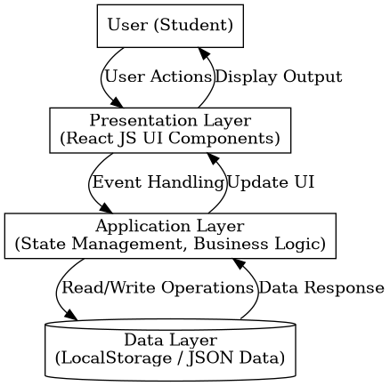

Description:
- The Presentation Layer handles user interaction and displays content.
- The Application Layer processes input and performs logic operations.
- The Data Layer manages structured data in JSON or localStorage format.
3.3 Use Case Diagram
1. What is a Use Case Diagram?
A Use Case Diagram visually shows:
- Actors → the users or external systems interacting with your application.
- Use Cases → the actions they can perform.
- Relationships → how those actions connect.
It helps you explain “Who does what” in your system.
2. Identify the Main Actors (for your Educational Website)
Actor | Description
Student/User | The main actor who views available seats, selects seats, reserves seats, and cancels reservations through the system.
Administrator (optional) | Manages seat data, monitors reservations, and updates seat availability in the system.
Guest/Visitor (optional) | Can view seat availability but may have limited access without booking functionality.

- Identify the Main Use Cases
Actor | Use Case
User | View Available Seats
User | Select Seat
User | Reserve Seat
User | Cancel Reservation
User | View Booking Confirmation
Administrator | Manage Seat Data
Administrator | Monitor Reservations
4. Define Relationships
Symbol | Meaning
Solid line | Association (Actor performs a use case)
<<include>> | A mandatory sub-task inside another use case
<<extend>> | An optional or conditional task
Example:
· “Reserve Seat” <<include>> “Confirm Booking”
· “View Confirmation” <<extend>> “Reserve Seat”

5. Draw the Diagram

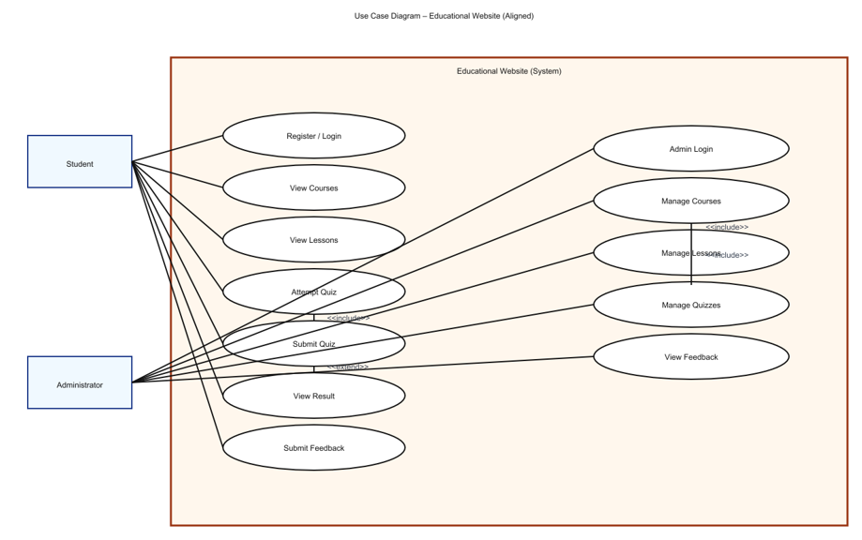
6. Example Explanation (Text Description)
Actors:
User: The main user who interacts with the system to view and reserve seats.
Administrator: The system manager who controls seat data and reservations.
Use Cases:
View Seats: User checks available seats.
Select Seat: User chooses a seat from the layout.
Reserve Seat: User books the selected seat.
Cancel Reservation: User cancels a booked seat.
View Confirmation: User checks booking status.
Manage Seats (Admin): Admin updates seat availability.
Relationships:
“Reserve Seat” includes “Confirm Booking”.
“View Confirmation” extends “Reserve Seat”.
3.4 Data Flow Diagram (DFD)
1. What is a Data Flow Diagram (DFD)?
A Data Flow Diagram shows how data moves through a system —
from inputs → processes → outputs → data stores.
It helps you visualize:
- Where the data comes from (source)
- What processes modify or use it
- Where it is stored
- Where it goes (destination)
2. DFD Symbols You’ll Use
Symbol | Meaning
Rectangle | External Entity (e.g., User)
Circle / Rounded Rectangle | Process (e.g., “Reserve Seat”)
Two Parallel Lines | Data Store (e.g., “Seat Data”)
Arrow | Data Flow (shows direction of data movement)
3. Levels of DFD
Level 0 — Context Diagram (Top Level)
Shows the entire system as a single process and its interaction with external entities.
Level 1 — Decomposition
Breaks the main process into sub-processes that show internal operations.
Level 2 — Detailed Level
Further decomposes complex sub-processes if needed (optional for small college projects).
4. Steps to Create a DFD
Step 1: Identify External Entities
- User
- Administrator
Step 2: Identify Main Processes
Display Seats
Select Time Slot
Reserve Seat
Confirm Booking
Cancel Booking
Step 3: Identify Data Stores
Seat Data Store
Booking Data Store
User Data Store
Step 4: Identify Data Flows
Select Time Slot
View Available Seats
Seat Selection
Booking Confirmation
Cancel Request

5. DFD for Educational Website
Level 0: Context Diagram
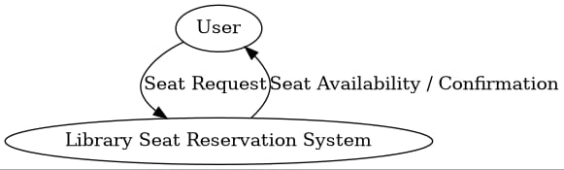

Explanation:
- The user provides input such as seat selection and reservation requests.
- The system processes the request and returns outputs like seat availability and booking confirmation.
- It gives a high-level view without showing internal details.
Level 1: Detailed System View
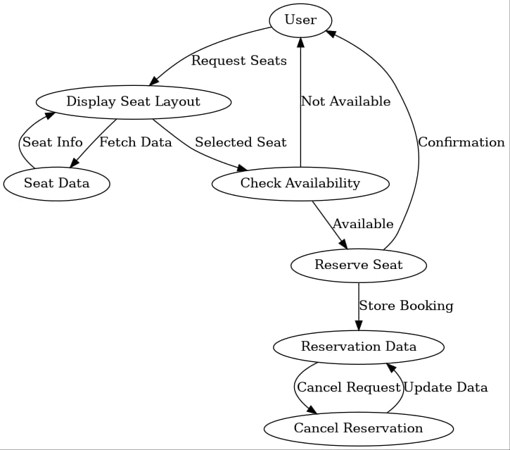
Explanation:
· Process P1: Fetches seat details from Seat Data Store.
· Process P2: Displays seat availability to the user.
· Process P3: Processes seat reservation using Reservation Data Store.
· Process P4: Updates and stores reservation details in Reservation Data Store.
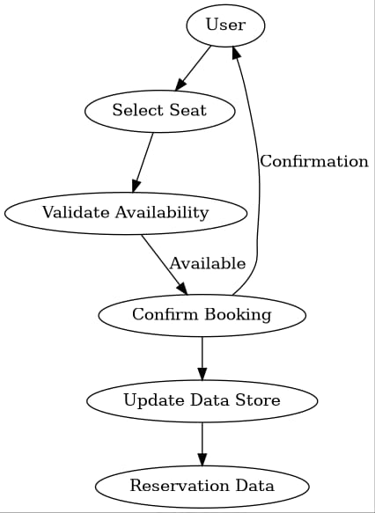

3.5 Entity Relationship Diagram (ERD)

Entities and Relationships:
• User (User_ID, Name)
• Seat (Seat_ID, Time_Slot, Status)
• Booking (Booking_ID, User_ID, Seat_ID, Time_Slot)

Relationships:
• A User can have multiple Bookings.
• A Seat can be booked multiple times at different time slots.
• Each Booking is associated with one User and one Seat.
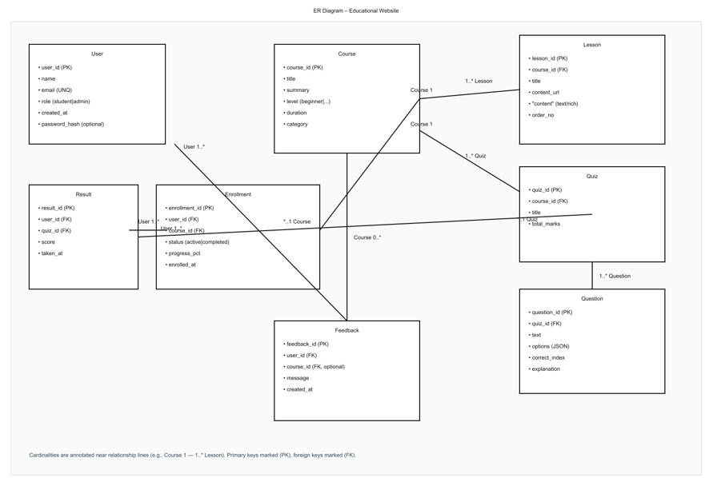
3.6 User Interface Design
The system consists of the following UI components:

a) Homepage
- Displays the title of the system
- Provides navigation options
- Entry point for users

b) Seat Layout Page
- Displays all available and reserved seats
- Uses colors to indicate seat status
  - Green → Available
  - Red → Reserved

c) Reservation Page
- Allows users to select seats
- Displays selected seat details
- Confirms reservation

d) Cancellation Option
- Allows users to cancel reserved seats
- Updates seat availability instantly

Chapter 4: System Implementation
4.1 Introduction
System design is an important phase in software development that focuses on defining the architecture, components, modules, interfaces, and data of the system. It provides a blueprint for implementing the system based on the requirements identified in the analysis phase.
The design of the Library Seat Reservation System ensures that users can easily view available seats, select seats, reserve them, and manage their bookings efficiently. The system is designed to be simple, user-friendly, and responsive using modern web technologies like ReactJS.
4.2 Development Tools and Technologies
Tool / Technology | Purpose
React JS | Used to build the user interface
JavaScript (ES6) | Used for implementing logic and functionality
CSS | Used for styling and layout design
Vite | Used as a build tool for fast development
Visual Studio Code | Used as code editor
Browser (Chrome/Edge) | Used for testing and execution
4.3 System Modules Description
Module | Description
Login Module | The login module allows users to enter their name and access the system. It ensures that only valid users can proceed to the dashboard.
Dashboard Module | The dashboard displays the overall seat availability and booking status. It provides an overview of the system.
Seat Management Module | This module allows users to view available seats, select seats, and perform reservation and booking operations.
Time Slot Module | This module allows users to select different time slots such as morning, afternoon, and evening.
Notification Module | This module displays messages to inform users about successful reservation, booking, or cancellation.
Each module is interconnected through JavaScript functions, ensuring smooth navigation and state management within the website.
4.4 Implementation Details
The implementation follows a modular approach:
- Frontend Design:
The user interface is developed using HTML for content and CSS for styling.
- Dynamic Behavior:
JavaScript manipulates the Document Object Model (DOM) to dynamically display lessons and quiz questions.
- Event Handling:
Buttons and inputs are linked to event listeners (e.g., onclick, onsubmit) to handle user actions.
- Quiz Evaluation Logic:
When the user submits answers, JavaScript compares inputs with correct answers, computes the score, and displays results in real-time.
- Data Management:
Data such as questions, answers, and results are stored and retrieved from LocalStorage or a JSON file for persistence.
4.5 Algorithm / Logic of Core Function
Algorithm for Seat Reservation:
Step 1: The user selects a time slot.
Step 2: The system displays available seats.
Step 3: The user selects a seat.
Step 4: The system checks availability.
Step 5: If available, the seat is reserved.
Algorithm for Booking Confirmation:
Step 1: The user clicks confirm booking.
Step 2: The system updates the seat status.
Step 3: The seat changes from reserved to booked.
Step 4: A confirmation message is displayed.
Algorithm for Cancel Booking:
Step 1: The user selects a booked seat.
Step 2: The user clicks cancel.
Step 3: The system updates the seat status.
Step 4: The seat becomes available again.
4.6 Security and Validation
The system includes basic validation to ensure proper user input. It prevents users from selecting invalid seats or performing incorrect actions. Users are allowed to cancel only their own bookings. Error messages are displayed when invalid actions are performed.
4.7 Integration
All modules are seamlessly integrated using event-driven programming. Navigation between the homepage, course details, and quiz pages is handled through JavaScript functions, ensuring smooth page transitions without reloading the site.
4.8 Output Screens
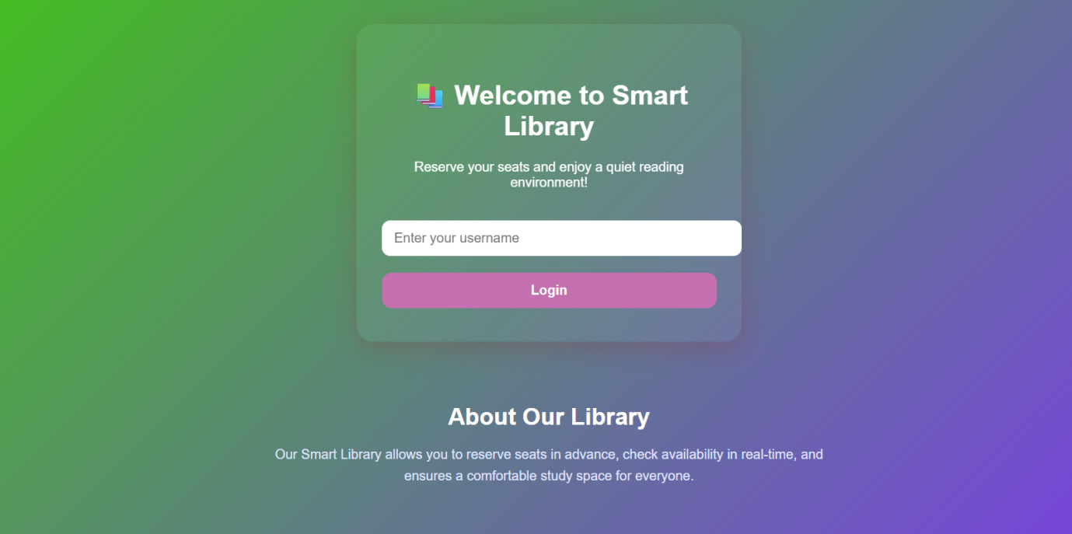

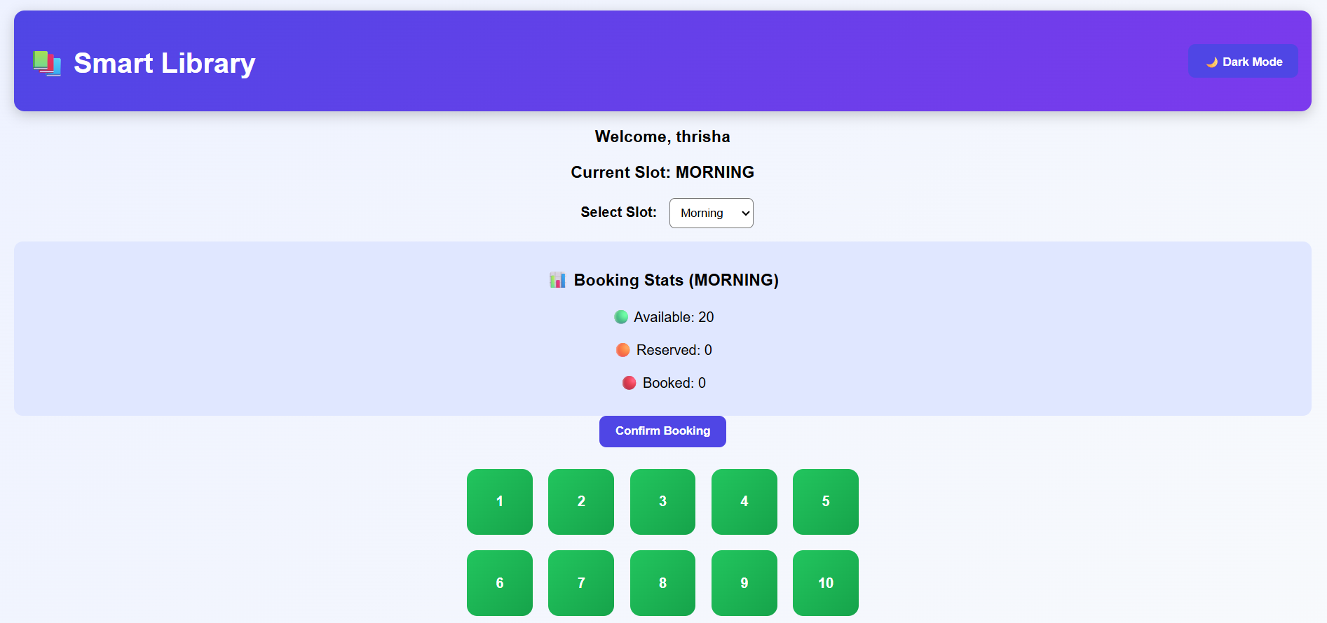

Chapter 5: System Testing
5.1 Introduction
System testing is a crucial phase that ensures the developed application meets all functional and non-functional requirements. It verifies whether the system performs correctly under various conditions.
For the Library Seat Reservation System, testing was conducted to validate the functionality of modules such as seat display, seat selection, reservation process, and cancellation.
5.2 Objectives of Testing
- To ensure that all modules (Seat Display, Reservation, Cancellation) function correctly.
- To identify and fix logical and runtime errors.
- To verify that user actions produce correct outputs.
- To ensure smooth performance across different browsers and device
5.3 Types of Testing Performed
a) Unit Testing
Each component and function was tested individually. For example, seat selection logic, reservation updates, and status changes were verified.
b) Integration Testing
All modules were combined and tested to ensure proper interaction between seat selection, reservation, and cancellation processes.
c) System Testing
The complete web application was tested to ensure all functional requirements were met — including seat booking and updating availability.
d) User Acceptance Testing (UAT)
The system was tested by users to ensure it is easy to use and meets requirements. Feedback was collected for improvements.
e) Cross-Browser and Device Testing
The system was tested on browsers like Chrome and Edge, and on different devices to ensure responsiveness.
5.4 Test Plan
Test ID | Module | Test Description | Type | Expected Output | Status
T01 | Seat Display | Display all seats | Functional | Seats visible | Pass
T02 | Seat Selection | Select available seat | Functional | Seat selected | Pass
T03 | Reservation | Book seat | Logic | Seat marked reserved | Pass
T04 | Cancellation | Cancel booking | Functional | Seat becomes available | Pass
T05 | Navigation | Move between pages | Integration | Smooth transition | Pass
T06 | Validation | Select invalid seat | Validation | Error message | Pass
T07 | Responsiveness | Mobile view | UI | Layout adjusts | Pass

5.5 Test Data and Execution
Sample seat data was created and stored using local storage or JSON. The system processed inputs such as seat selection and reservation requests. The outputs were verified by comparing expected and actual results.
5.6 Error Handling
· Prevents selecting already reserved seats
· Displays alerts for invalid actions
· Uses conditional checks to avoid errors
· Handles unexpected inputs effectively

5.7 Performance and Usability Testing
.· Performance: Fast response during seat selection and booking
· Usability: Simple interface for easy navigation
· Accessibility: Clear layout and readable design

5.8 Results and Observations
All modules worked correctly. The system performed efficiently across devices, and users found it easy to use. No major errors were identified.

Chapter 6: Results and Discussion
6.1 Introduction
This chapter presents the results obtained after implementing the Library Seat Reservation System and evaluates its performance.
6.2 System Outputs
The system produced the following outputs:
- Homepage displays seat layout
- Seat selection page allows users to choose seats
- Reservation updates seat status instantly
- Confirmation displayed after booking
6.3 Performance Analysis
· Responsiveness: Fast loading interface
· Accuracy: Correct seat reservation updates
· Stability: No errors during repeated operations
· Compatibility: Works across multiple browsers

6.4 User Feedback
Users found the system:
- Easy to use
- Fast and responsive
- Helpful for managing seat reservations
Suggestions include adding login and database features.

Chapter 7: Conclusion and Future Enhancement
7.1 Conclusion
The Library Seat Reservation System successfully demonstrates how web technologies can be used to manage seat booking efficiently. The system provides a simple and user-friendly interface for viewing, reserving, and canceling seats.
All modules function correctly, and the system meets its objectives of providing an efficient seat management solution.
7.2 Limitations
· No user authentication system
· No database integration
· Limited advanced features
7.3 Future Enhancement
· Add user login and authentication
· Integrate database (MySQL / MongoDB)
· Provide real-time updates
· Develop mobile application
· Add admin dashboard

Chapter 8: References
8.1 Books & Journals
- Web Technologies: HTML, CSS, JavaScript, PHP, Java, JSP, XML, and AJAX — Uttam K. Roy, Oxford University Press.
- Learning Web Design — Jennifer Niederst Robbins, O’Reilly Media.
- E-Learning and the Science of Instruction — Ruth C. Clark & Richard E. Mayer, Wiley.
8.2 Online Resources
- MDN Web Docs — https://developer.mozilla.org
- W3Schools — https://www.w3schools.com
- Bootstrap Official Documentation — https://getbootstrap.com
- JavaScript.info Tutorials — https://javascript.info
- GeeksforGeeks Web Development Articles — https://www.geeksforgeeks.org
8.3 Tools & Frameworks Used
- Editor: Visual Studio Code
- Languages: HTML5, CSS3, JavaScript (ES6)
- Framework: React JS
- Database (Future Scope): Local Storage
- Browser: Google Chrome / Microsoft Edge

